[Youtube Walkthrough: <https://www.youtube.com/watch?v=k_eg_Uy2JtQ>

CHAPTER 11

**Google Analytics 4 Flood It! Assignment**

By Nathan David

**Overview**

LEARNING OBJECTIVES

* Practice navigating Google Analytics 4.
* Answer business questions using Google Analytics 4 data.
* Interpret mobile app analytics and provide performance insights.

BACKGROUND  
Mobile apps are an integral component of owned media. Mobile app marketing technology tools collect critical digital marketing data. Armed with mobile app analytics data, analysts drive better results for businesses.

**Instructions**  
You have been hired as a digital marketing analyst for Flood It!. Please get familiar with your employer by exploring their mobile app, [Android](https://play.google.com/store/apps/details?id=com.labpixies.flood&hl=en) and [iOS](https://itunes.apple.com/us/app/flood-it!/id476943146?mt=8).

Flood It! is a real puzzle game in which you have to flood the whole game board with one color in fewer than the allowed steps. Flood It! has Google Analytics 4 implemented. The mobile

app data is flowing to the Google Analytics 4 demo project. The data available is typical of what you might see for a gaming app with in-app purchases.

**Step 1**

Gain access to a Google Analytics 4 demo account for Flood It!. [Instructions for accessing this demo account](https://support.google.com/analytics/answer/6367342?hl=en) are available from Google. Make sure when you access the demo account you navigate to the Property ‘GA4 - Flood-It!’ (see images below).

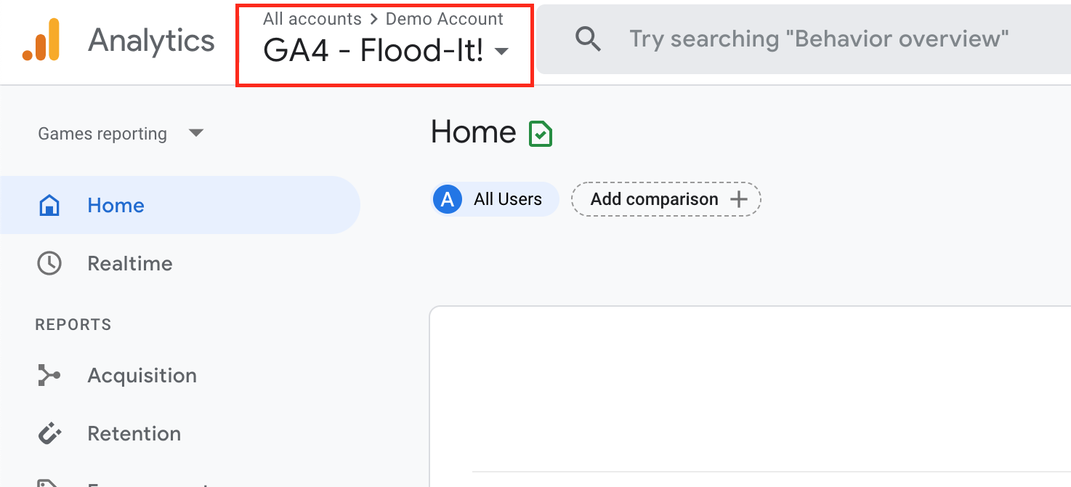

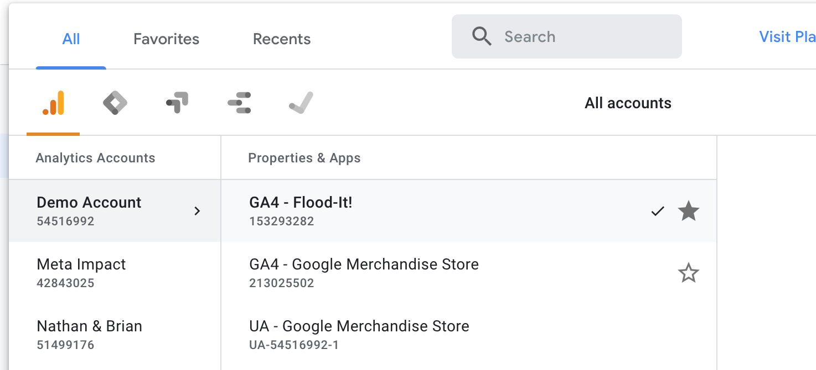

**Step 2**

Your manager is interested in the mobile app performance for Flood It! for the month of April 2021. When you open the Google Analytics 4 analytics dashboard, make sure you adjust the date filter in the upper right-hand corner to start on July 1, 2022, and end on July 31, 2022.

Your manager has asked you to answer the following questions using data from the Google Analytics 4 demo account.

1. How many new users (in thousands) did the Flood It! mobile app have in April 2021?

|  |
| --- |
| New users: 10K  Screenshot: |

2. How many new users were acquired through CPC (cost per click) in July 2022?

|  |
| --- |
| New users acquired through CPC: 789  Screenshot: |

3. How many returning users (in thousands) did the Flood It! mobile app have in July 2022?

|  |
| --- |
| Returning users: 11K  Screenshot: |

4. How many post_score events occurred in July 2022?

|  |
| --- |
| 36,350  Screenshot: |

5. In minutes and seconds, what was the average engagement time?

|  |
| --- |
| 5m 24s  Screenshot: |

6. Which event name had the highest count in July 2022?

|  |
| --- |
| **screen_view**  Screenshot: |

7. What was the total revenue in July 2022?

|  |
| --- |
| Total revenue: $1.83  Screenshot: |

8. What was the average revenue per paying user in July 2022?

|  |
| --- |
| $0.00  Screenshot: |

9. Flood It! uses first opens as a proxy for app installs. What was the first_open event count in July 2022?

|  |
| --- |
| 9,698  Screenshot: |

10. Flood It! uses an audience called “Crashing Users” to track users that experienced an app crash. How many “Crashing Users” were there in July 2022?

|  |
| --- |
| Crashing Users: 411  Screenshot: |